**School Emergency Drills**   
Documentation

**School Name:** Mason

**Type of drill: Fire Drill**

**Number of this type of drill this school year: 3**

**Enter date of drill:** **5-10-21**

**Time of drill 10:50** AM ☐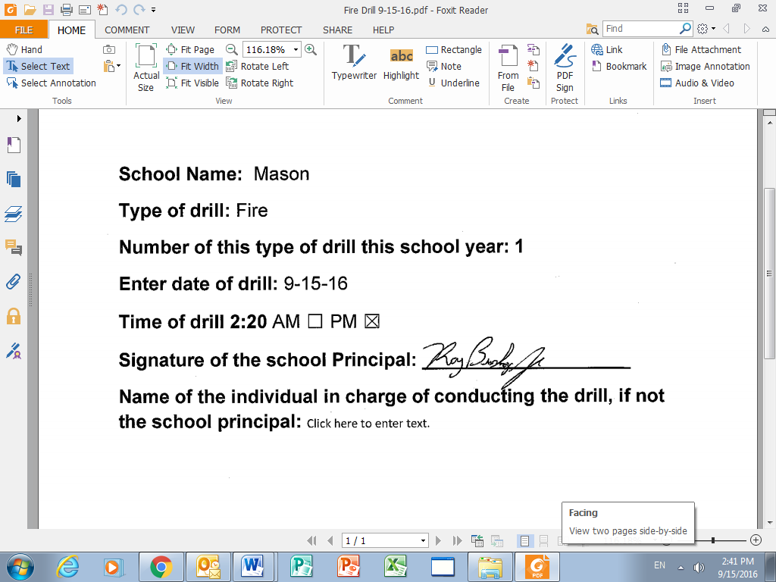

**Signature of the school Principal:**

**Name of the individual in charge of conducting the drill, if not the school principal:** Click here to enter text.